Encouraging environmental stewardship for the Cocohatchee estuary that fosters a balance of nature and community through science, education, safe navigation and local action.

For the Year Ending on December 31, 2015

Annual Report
2015
Estuary Conservation Association

Protecting Our Estuary
The Estuary Conservation Association (ECA) is the only local non-profit organization dedicated to the conservation of wildlife and natural resources within the Cocohatchee estuary.
This annual report highlights ECA’s recent work to help conserve and restore the estuary. ECA encourages local residents, boaters and environmental enthusiasts to join the organization as a member. For more details, please read through the enclosed report and visit ECA’s website at www.estuaryconservation.org.
2015 ECA Board of Directors and Advisors
Pictured (Left to right): Len Crame, Gary Lytton, Mac Hatcher, Alan Ritchie, Kathy Worley, Erin Shelton, Darline Hillard, Alan (Butch) Yarusevich, Bill Rowe. Not pictured: Debbie Laites, Ron Vuy, Captain Mark Garcy, and Dr. Michael Savarese.

Coastal Forums - 2015
Helping Educate and Increase Community Awareness through the ECA Coastal Forum Series available free to the public.
In partnership with Walmart, Vi at Bentley Village, The Halstatt Charitable Foundation and the Pelican Isle Yacht Club, ECA hosted the sixth annual series of Coastal Forums hosted at Bentley Village and Pelican Isle Yacht Club. Featured topics and speakers included:
January 2015: The Lionfish Invasion with Sea Grant Agent Bryan Fluech discussing the challenges of managing a new marine invasive species in our local waters, and Effects of Sea Level Rise in Southwest Florida with Dr. Mike Savarese from Florida Gulf Coast University, sharing results of recent research on sea level rise in Rookery Bay National Research Reserve.
February 2015: Manatee Behavior and Ecology with Rookery Bay Director Gary Lytton discussing the life history of a local endangered marine mammal, and Tracking Sea Turtles in Southwest Florida with Dr. Jeff Schmid from the Conservancy of Southwest Florida sharing results of his ongoing research tagging and tracking sea turtles in local waters.
March 2015: Green Boating II: Latest Advances in Environmentally Friendly Technology and Design with a panel of invited local experts from Collier Marine Industries Association, sharing recent improvements in marine engine fuel efficiency and reduction in emissions, environmentally friendly bottom paints, and navigation technology that enhances mariner safety and protection of marine and coastal resources.
April 2015: Mangrove Ecology and Restoration with Gary Lytton, Director of Rookery Bay National Estuarine Research Reserve, sharing lessons learned from restoring mangrove forested wetlands, and Red Tide: Impacts on Human Health and Wildlife with Rhonda Watkins, Environmental Specialist from Collier County, sharing insights into research on the microscopic organism that can cause massive fish kills and affect human health along our beaches.

Making a Difference: Building New Reefs to Restore Our Estuary
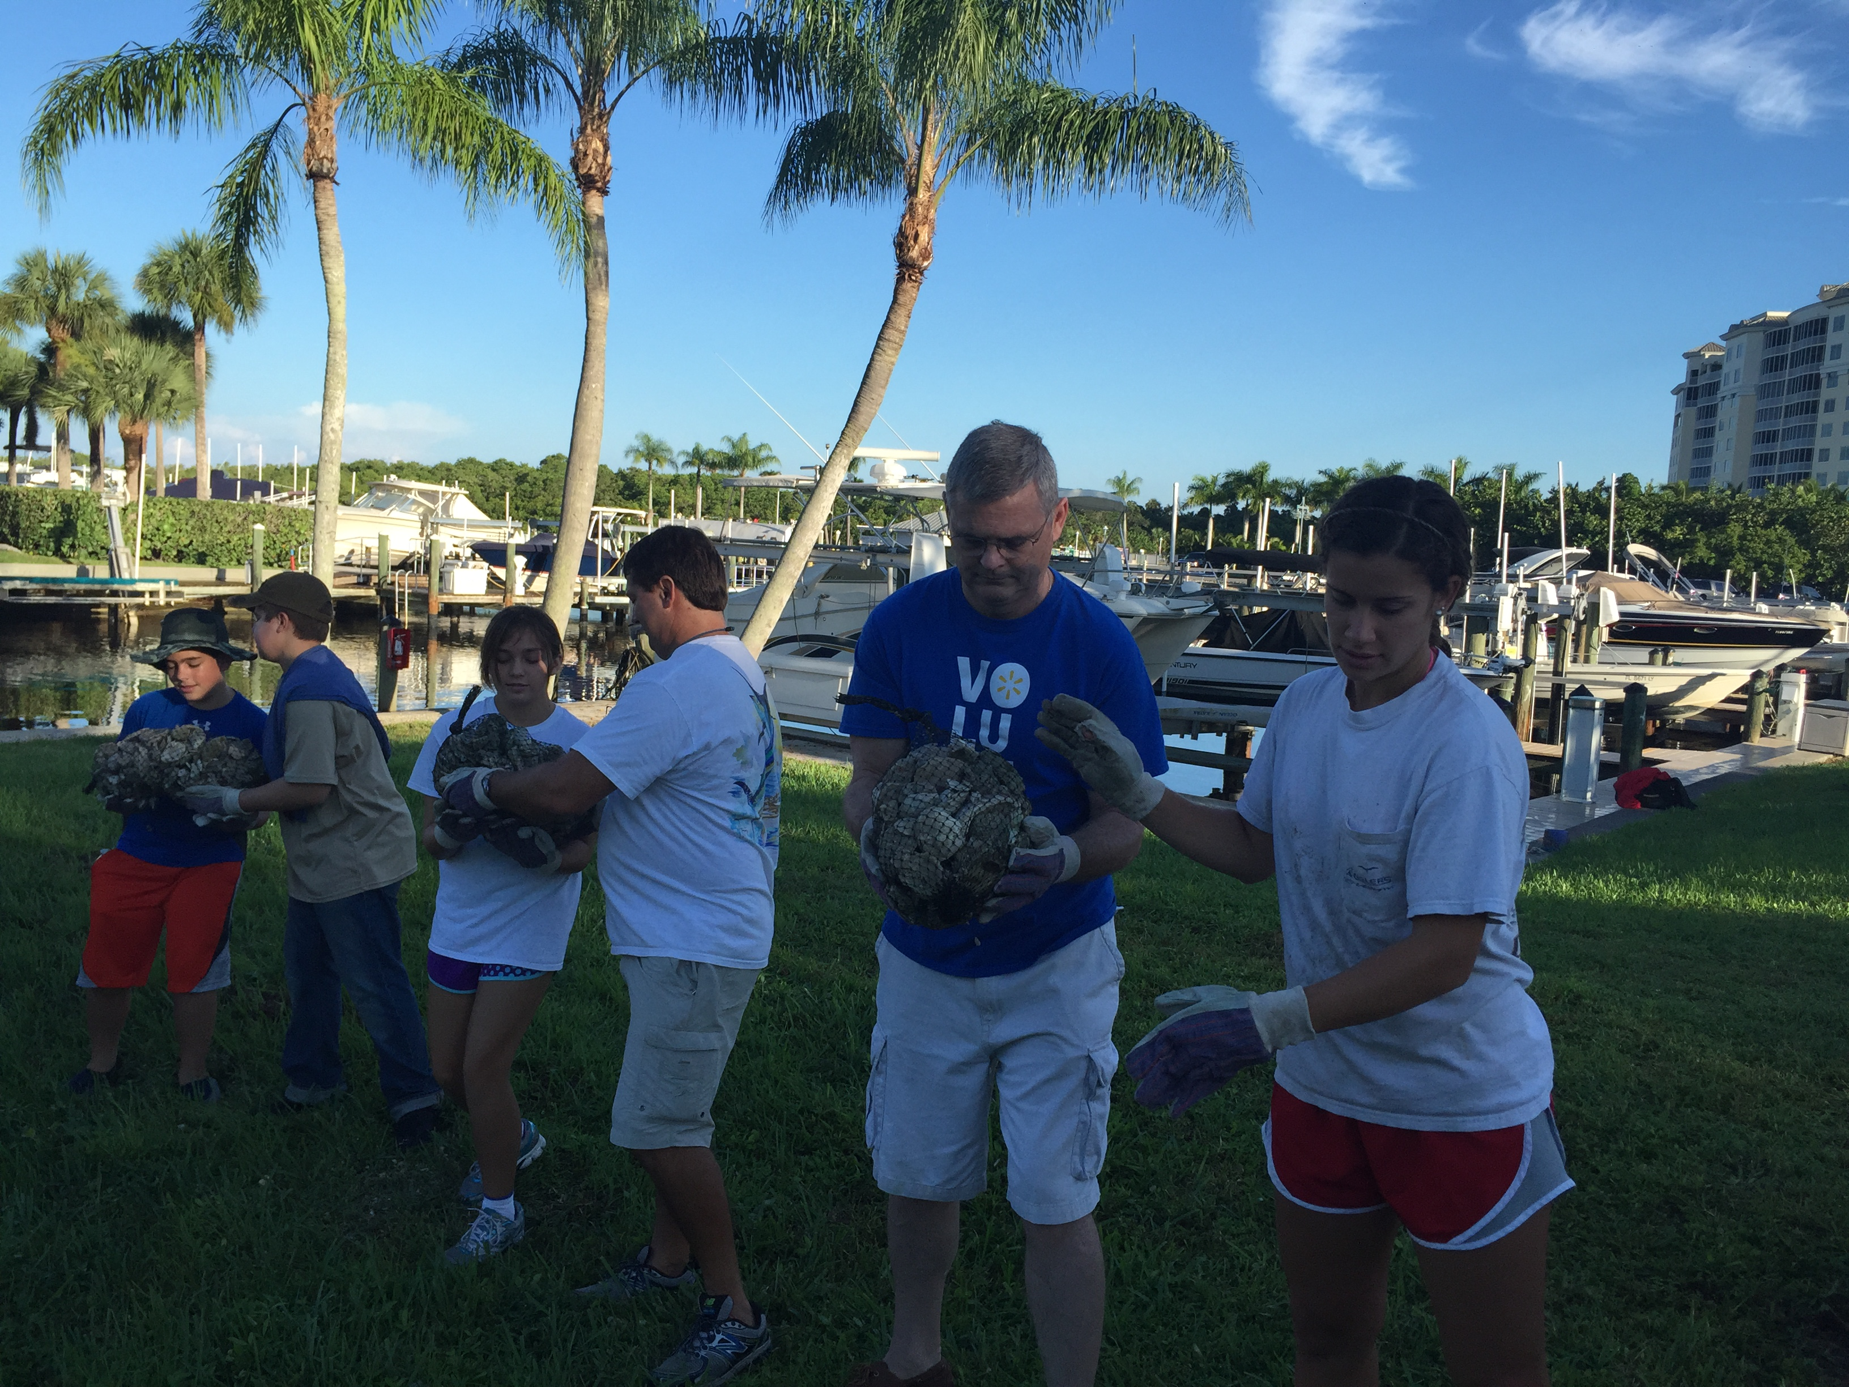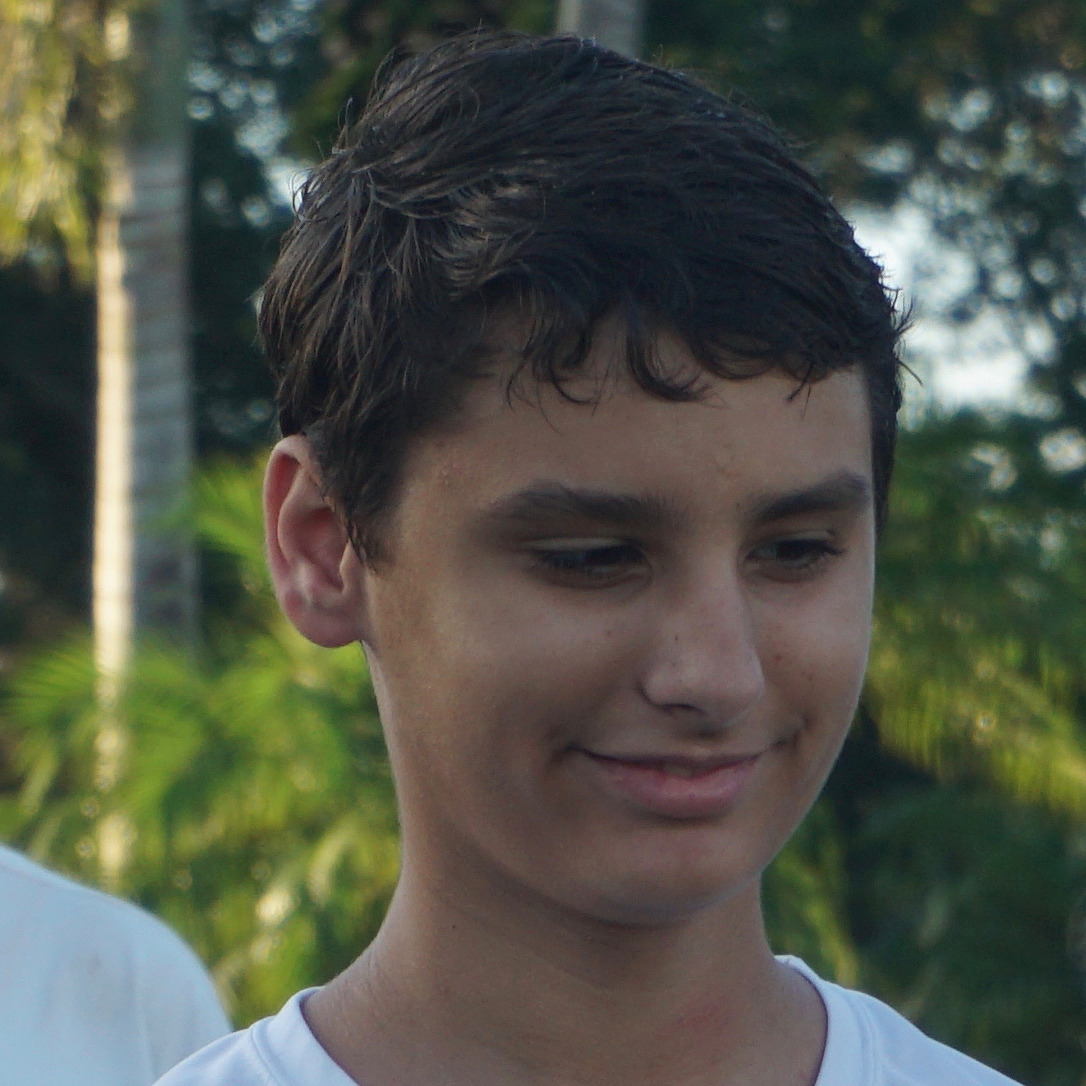
Larry Gram, Walmart North Naples manager, helps volunteers with shell bags. Eagle Scout candidate John Spilker.
Following up on a successful reef building project in the Cocohatchee estuary last year, ECA partnered with the Friends of Rookery Bay, Inc., Walmart Foundation, and Florida Gulf Coast University (FGCU) to secure a portion of the grant to provide needed funds for building two more oyster reefs in the estuary.
Completed in August 2015, the two reefs were built using over 500 bags of fossil shell material purchased with Walmart grant funds. ECA and partners again worked with a local Boy Scout troop to support an Eagle Scout service project. John Spilker, an Eagle Scout candidate, and Troop 243 participated in the reef project and supported the effort with volunteers and supplies. Pelican Isle Yacht Club and Naples Marina and Excursions helped provide support.
Scientists from FGCU helped design the reef project, based on years of successful experience in similar environmental restoration efforts across Southwest Florida. Once placed in local waters, shell bags are colonized by living oyster spat and eventually become living reefs, improving water quality by filtering organic material and providing important refuge for fish and shellfish.
For more details on ECA’s oyster reef restoration projects, see www.estuaryconservation.org.
Wiggins Pass Navigation: Monitoring Local Conditions for Boaters
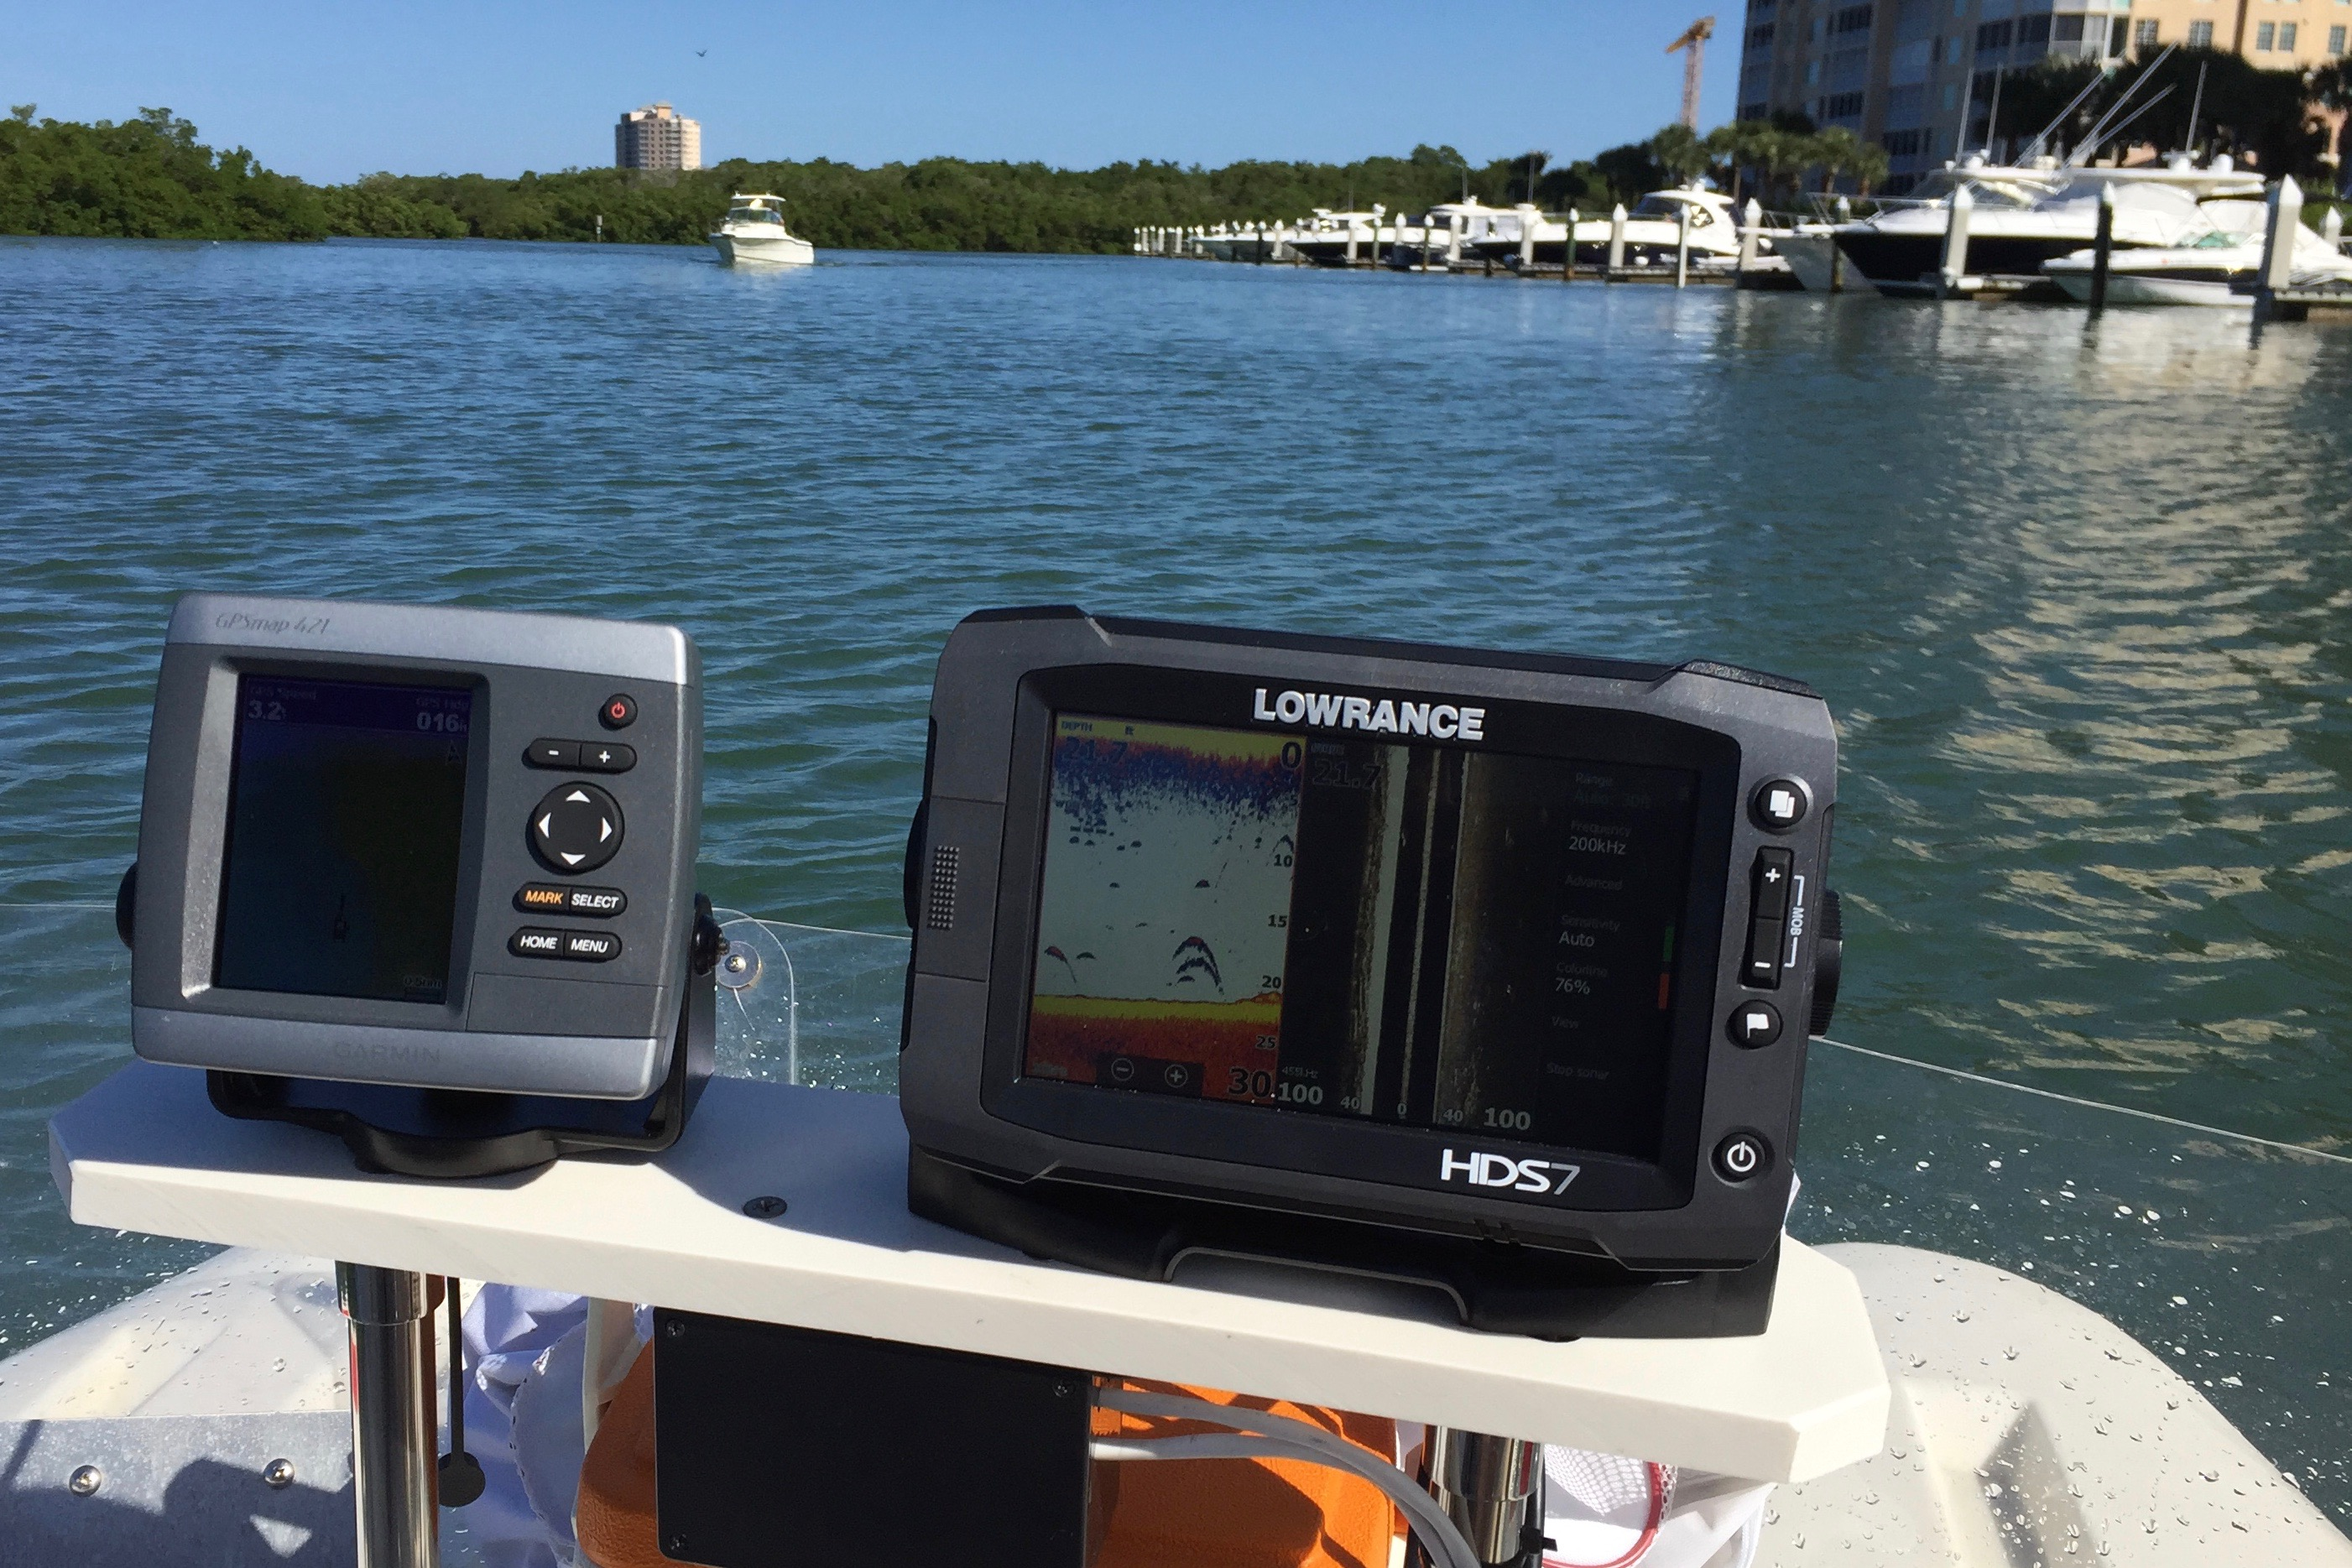
Following the successful dredging of Wiggins Pass in 2015 by Collier County’s Coastal Zone Management Department, ECA continues to work with local partners to monitor channel depth and navigation conditions in the Pass. This includes the recently completed interim dredge of the Pass.
ECA meets with county officials on a periodic basis to review any changes in the Pass, current location of channel markers, and to coordinate with local recreational boating interests, residents, hotels, and marinas with shared interests in the safe navigation of the Wiggins Pass inlet.
For more details of the project, and for monthly updates on the navigation issues in the Pass conducted by ECA volunteers, see www.estuaryconservation.org.

ECA Partners with Coastal Angler Magazine
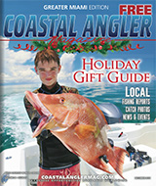
ECA has established a new partnership with Mike Weber, Publisher of the Collier County Edition of Coastal Angler Magazine, to publish a series of monthly articles that highlight the work of ECA.
Recent Coastal Angler articles written by ECA have included updates on the dredging of Wiggins Pass, Oyster Reef Restoration, and ECA’s Coastal Forum series scheduled for 2016.
ECA’s Science and Restoration Committee, led by ECA Board member Mac Hatcher, recently reviewed current research on Vibrio vulnificus, a microscopic bacteria found in local coastal waters that can cause infections in humans. Mac’s article on Vibrio will appear in the February 2016 edition of Coastal Angler magazine.
ECA works with state and local officials to help educate local residents and implement actions to reduce pollutants, such as dog waste, into coastal waters from upstream locations. For more information, see ECA’s full report at www.estuaryconservation.org

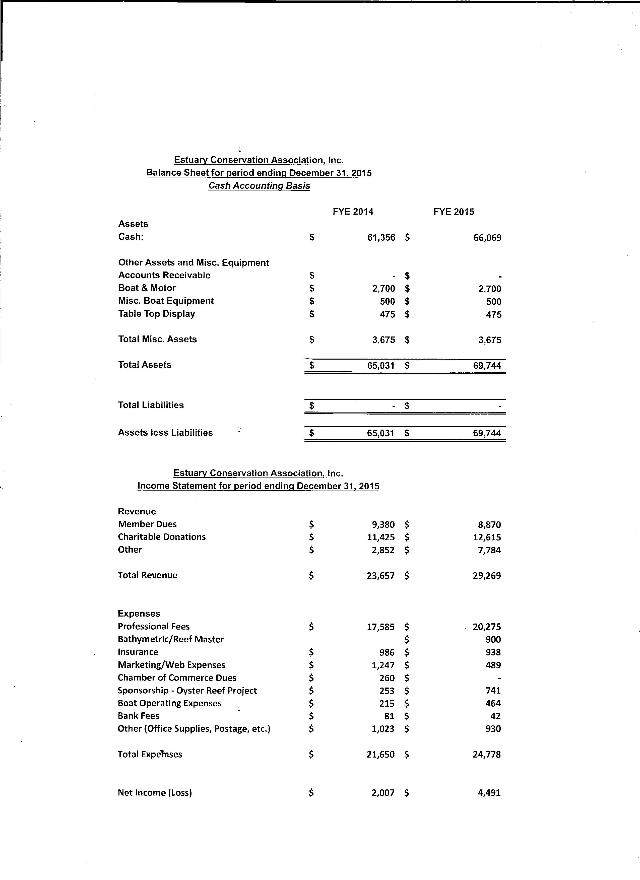
ECA Adds New Board Members
ECA proudly announces the addition of Ms. Debbie Laites of Naples to the Board of Directors.

ECA 2015 Board Members:
Alan Ritchie (President)
Len Crame (Vice President)
Kathy Worley (Secretary)
Bill Rowe (Treasurer)
Capt. Mark Garcy
Mac Hatcher
Darline Hillard
Dr. Michael Savarese
Debbie Laites
Alan (Butch) Yarusevich
Advisors/Staff: Gary Lytton, Erin Shelton

An Evening with
Dr. Nick Whitney in April 2015
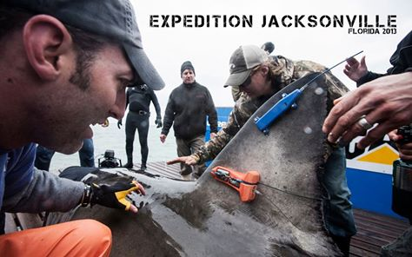
Dr. Nick Whitney, Staff Scientist and Manager for Mote Marine Lab
In partnership with Aqua at Pelican Isle and the LaPlaya Beach and Golf Resort, ECA sponsored a reception and seminar featuring Dr. Nick Whitney from Sarasota’s Mote Marine Laboratory. The evening event was an exclusive invitation only opportunity for ECA’s members, the ECA Board of Directors, partners and sponsors.
Dr. Whitney shared stories and perspectives from his research expeditions, featuring the use of satellite tags to track the movements of sharks in coastal and offshore waters.
Dr. Whitney’s research has helped improved understanding of how sharks behave in natural conditions and has also led to increased awareness of catch and release methods that improve survival for sharks in the wild. ECA raised funds through a silent auction to help support ongoing projects.

Wiggins Pass Navigation: Monitoring Local Conditions for Boaters
Following the successful dredging of Wiggins Pass in 2015 by Collier County’s Coastal Zone Management Department, ECA continues to work with local partners to monitor channel depth and navigation conditions in the Pass. This includes the recently completed interim dredge of the Pass.
ECA meets with county officials on a periodic basis to review any changes in the Pass, current location of channel markers, and to coordinate with local recreational boating interests, residents, hotels, and marinas with shared interests in the safe navigation of the Wiggins Pass inlet.
For more details of the project, and for monthly updates on the navigation issues in the Pass conducted by ECA volunteers, see www.estuaryconservation.org.

ECA Partners with Coastal Angler Magazine
ECA has established a new partnership with Mike Weber, Publisher of the Collier County Edition of Coastal Angler Magazine, to publish a series of monthly articles that highlight the work of ECA.
Recent Coastal Angler articles written by ECA have included updates on the dredging of Wiggins Pass, Oyster Reef Restoration, and ECA’s Coastal Forum series scheduled for 2016.
ECA’s Science and Restoration Committee, led by ECA Board member Mac Hatcher, recently reviewed current research on Vibrio vulnificus, a microscopic bacteria found in local coastal waters that can cause infections in humans. Mac’s article on Vibrio will appear in the February 2016 edition of Coastal Angler magazine.
ECA works with state and local officials to help educate local residents and implement actions to reduce pollutants, such as dog waste, into coastal waters from upstream locations. For more information, see ECA’s full report at www.estuaryconservation.org.

